Practical 4:

**Quick Questions:**

1. Linear
2. Stable sorting algorithms preserve existing relative order of elements when comparing  equal keys.
3. A
   1. Comparison vs. Non comparison
   2. Time complexity
   3. Space complexity
   4. Stability
   5. Internal vs. External
   6. Recursive vs. Non-recursive

|  |  |  |  |
| --- | --- | --- | --- |
| **Input size** | **Selection sort** | **Insert sort** | **Bogo sort** |
| 10 | 363 | 365 | 463 |
| 100 | 279 | 320 |  |
| 1000 | 702 | 719 |  |
| 10 000 | 781 | 890 |  |

|  |  |
| --- | --- |
| **Input size** | **Quick sort** |
| 10 | 252 |
| 100 | 284 |
| 1000 | 939 |
| 10 000 | 1040 |

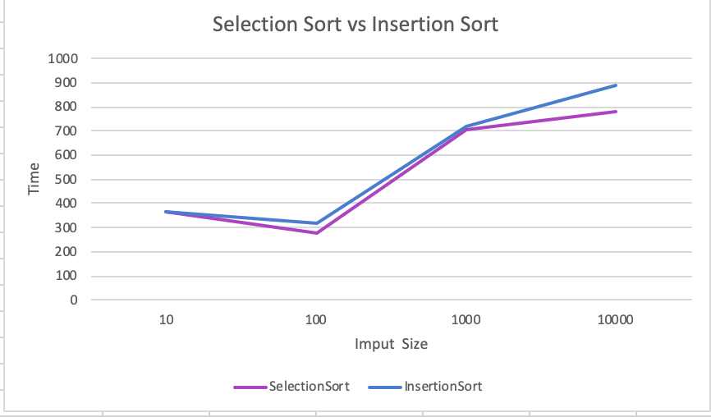

BogoSort was very slow and is a very ineffective algorithm. It took very long to compile compared to the other sorts.

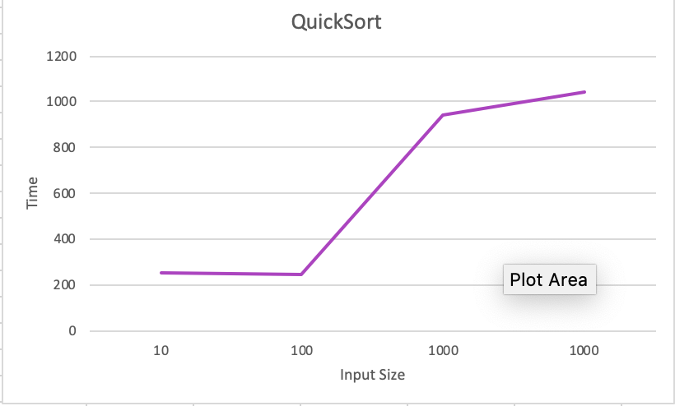

Time complexity for each sort:

* SelectionSort: O(n^2)
* InsertSort: O(n)
* BogoSort: O(n)